Regulations:
A17

H.T No

Sreenidhi Institute of Science and Technology
(An Autonomous Institution)
Code No: 6BC03 Date: 31-May-2018 (FN)

B.Tech I-Year II-Semester External Examination, May/June - 2018 (Regular)
ENGINEERING MECHANICS (CIVIL & ME)

Time: 3 Hours Max.Marks:75

Note: a) No additional answer sheets will be provided.
b) All sub-parts of a question must be answered at one place only, otherwise it will not be valued.
c) Missing data can be assumed suitably.

Part - A Max.Marks:25

Answer all QUESTIONS.

1. | Explain resolution of forces. | [3M]
2. | List the various supports and their reactions. | [3M]
3. | Distinguish between perfect truss and imperfect truss. | [3M]
4. | State Pappu's theorem to determine the area of surface and volume of solid. | [3M]
5. | A car accelerates uniformly from a speed of 30 Km/hr to a speed of 75 Km/hr in 5 seconds. Determine the acceleration of the car. | [3M]
6. | State “Varignon’s theorem. | [2M]
7. | What is work energy principle? Explain. | [2M]
8. | What is the mass moment of inertia of a rod length ‘L’ about its centroidal axis? | [2M]
9. | List the laws of dry friction. | [2M]
10. | What is the difference between the rectilinear motion and curvilinear motion? | [2M]
Part – B Max.Marks:50
ANSWER ANY FIVE QUESTIONS. EACH QUESTION CARRIES 10 MARKS.

11. | a) | A boat is moved uniformly along a canal by two horses pulling with forces P= 100 kg and Q= 120 kg acting under an angle α = 60º as shown in fig.01. Determine the magnitude of the resultant pull on the boat and the angles β and γ .  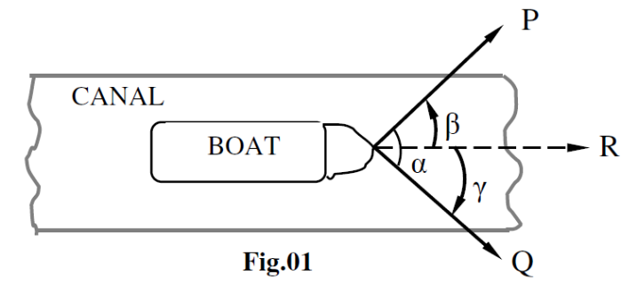 | [5M]
 | b) | A 200N sphere is resting in a trough as shown in fig.2. Determine the reactions developed at contact surfaces. Draw FBD.  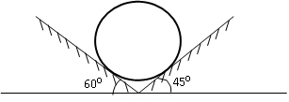 Fig.2 | [5M]
12. |  | Determine the centroid of following plane area as shown in Fig. 3.  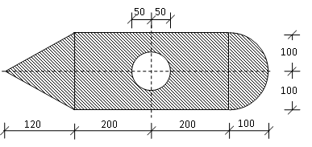  Fig.3 | [10M]
13. |  | The truss in Fig.4 is pinned to the wall at point F, and supported by a roller at point C. Calculate the force (tension or compression) in members BC, BE, and DE.  C  80kN  60kN  4m  4m  4m  F  E  D  5m  Fig.4  11  B | [10M]
14. |  | The cross section of a plain concrete culvert is as shown in fig.5. Determine the moment of inertia about its horizontal centroidal axis.  40  40  180  O  100  65  100  Fig. 5 | [10M]
15. |  | A ball is dropped from the top of a tower 30 m height .At the same instant a second ball thrown up from the ground with initial velocity of 15 m/sec. When and where do they cross each other and with what relative velocity? | [10M]
16. |  | Two weights 400 N and 100 N are connected by a thread and move along a rough horizontal plane under the action of a force 200N, applied to the first weight of 400N as shown in Fig.6. The coefficient of friction between the sliding surfaces of the weights and the plane is 0.25.Determine the acceleration of the weights and the tension in the thread using work-energy equation.  200N  100N  400N  Fig.6 | [10M]
17. |  | Referring to the fig.7, the coefficients of friction are as follows: 0.25 at floor, 0.3 at the wall and 0.2 between the blocks. Find the minimum value of a horizontal force ‘P’ applied to the lower block that will hold the system in equilibrium.  500 kg  60⁰  P  1000 kg  Fig.7 | [10M]
18. |  | Derive the mass moment of inertia of a solid right circular cone of base radius R and height H with respect to its geometric axis of rotation. | [10M]
-- 00 -- 00 –

